**Change PII Request Flow - by Shareholder**

**Title:**  
Enable Shareholders to Request Changes to PII (Personal Identifiable Information)

**Description:**  
We need to implement the full workflow that allows a shareholder (or authorized party) to request updates to their PII data (such as name, email, address, etc.). These requests will be reviewed by a *Rialto Operator*, who will approve or reject the change. Once approved, changes will be applied and all relevant parties will be notified.

**🔹 Actors:**

* **Shareholder user** (logged-in shareholder user)
* **Rialto Operator** (admin role)
* **Company** (where the shareholder has positions)

### 🔹 ****Workflow Overview (Part 1: Request Creation – Shareholder only)****

This user story refers specifically to PII change requests **initiated by the shareholder themselves** (i.e., users logged in as natural persons). Future stories will cover requests initiated by other roles (CEO, Board Member, etc.).

⚠️ **Note:** If the logged-in user is associated with a **legal entity** (i.e., Legal Shareholder), some types of changes may not be allowed. The UI must block or restrict those flows accordingly.

#### ****Step 1 – Access PII Change Request Flow****

* Logged-in shareholder user clicks a button labeled:  
  **Request Change to PII**

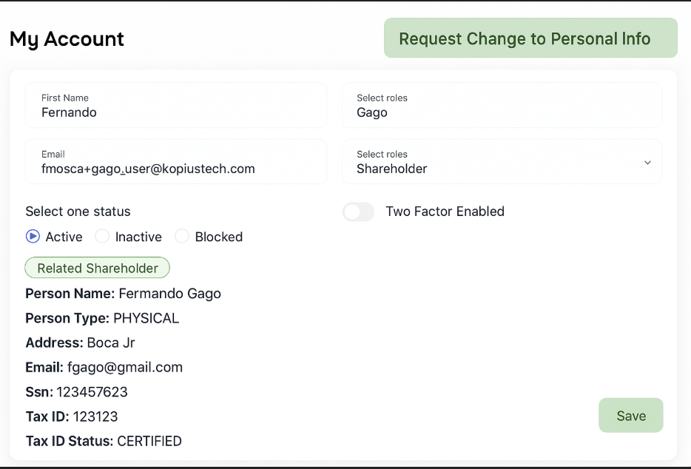

#### ****Step 2 – Select Type of Change (Dropdown Menu)****

* A **dropdown menu** appears with the following options:

- Legal Name

- Email

- Mailing Address

- SSN / Tax ID

- Date of Birth

- Merge Accounts

- Phone Number

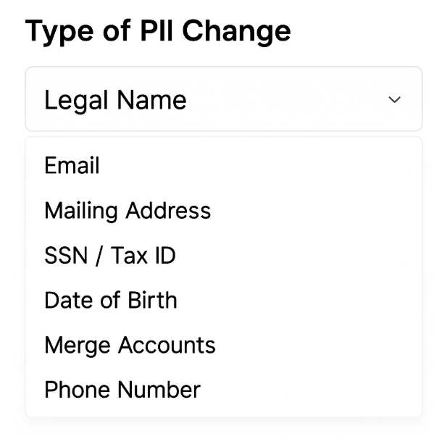

* ⚠️ At this point, **only the dropdown is shown**. No additional fields are visible yet.

#### ****Step 3 – Display Additional Fields Based on Selection****

For each option selected from the dropdown, the form dynamically renders additional fields or requirements:

##### ➤ **Legal Name**

* Upload field for **legal supporting documents**
  + e.g. Government ID, Marriage Certificate, Court Order
* Optional comment field (reason or explanation)

##### ➤ **Email**

* Input field for **new email address**
* Optional checkbox: “Mark as default email”
* ⚠️ Optional: ability to add **second email address** instead of replacing

##### ➤ **Mailing Address**

* Input fields for:
  + Street address
  + City
  + State
  + ZIP/Postal Code
  + Country
* (This may eventually become self-service and not require TA review)

##### ➤ **SSN / Tax ID**

* Input for updated SSN/Tax ID
* Upload field for **legal document proof**
* Mandatory reason for change
* ⚠️ This type of request may require **KYC verification** in the future

##### ➤ **Date of Birth**

* Input for new date
* Upload for **supporting documentation**
* ⚠️ May trigger re-verification or future KYC step

##### ➤ **Merge Accounts**

* Autocomplete field to **search/select the other shareholder** to be merged
* Dropdown to select which email will become default
* There should be preferably an algorithm that identifies if both email addresses are similar so that the Rialto operator knows that the reason for the merge is an account/shareholder duplication
* Optional comment/justification

##### ➤ **Phone Number**

* Input for new number
* Optional checkbox: "Replace existing" or "Add as secondary"
* ⚠️ Might not require manual review (self-service)

#### ****Step 4 – Submit Request****

* Once all required fields are completed and validated, the user clicks **Submit Request**
* A confirmation message appears in the UI:  
  "Thank you. Your request has been submitted and is being reviewed."

#### ****Step 5 – Email Notifications****

Once the request is submitted, the system triggers two automatic emails:

##### ➤ **To the Shareholder (Confirmation Email)**

**Subject:** Your PII Change Request Has Been Received  
**Body:**

Dear [Shareholder Name],

We have received your request to update your personal information. Our team is currently reviewing the details and any supporting documentation provided.

You will be notified once the request is approved, rejected, or if further information is needed.

Best regards,  
The Rialto Transfer Agent Team

##### ➤ **To the Rialto Operator (Backoffice Alert)**

**Subject:** New PII Change Request Submitted  
**Body:**

A new PII change request has been submitted by shareholder [Shareholder Name] (ID: XXXX).

Requested change: [Type: e.g. Legal Name]

Please review and process the request through the Operator Dashboard.

### ****Workflow Overview – Part 2: Backoffice Review (Rialto Operator Dashboard)****

#### Step 1 – Notification of New Request

* When a PII request is submitted, **Rialto Operators** will see a notification icon with a red dot or counter indicating **pending requests**.
* The icon is displayed in the **top right corner of the dashboard**, next to the user profile (see reference image below: next to "Fer").

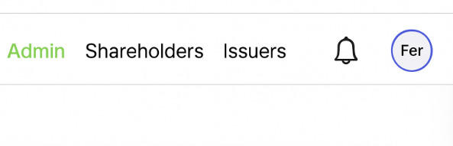

The Show Notifications link and the Bell icon should only by shown if there ARE new notifications/not approved notifications

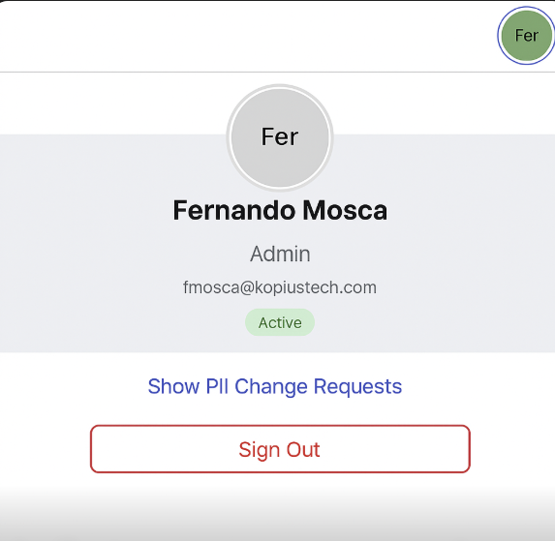

The same link should be accessible through here]

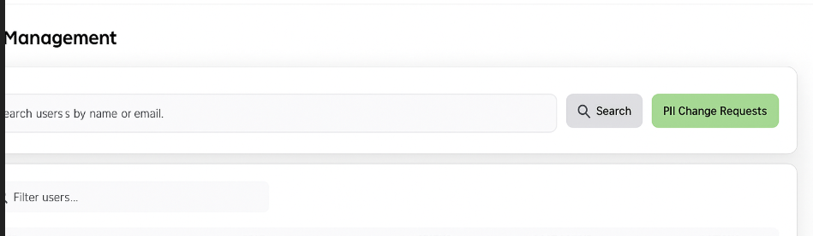

#### Step 2 – Accessing the PII Change Queue

* Clicking the notification or navigating to **Admin > PII Requests** opens the list of pending requests.
* Each request entry shows:
  + Shareholder Name and ID
  + Type of change (e.g., Legal Name, Email, etc.)
  + Submission date and status
  + Action button: View Details

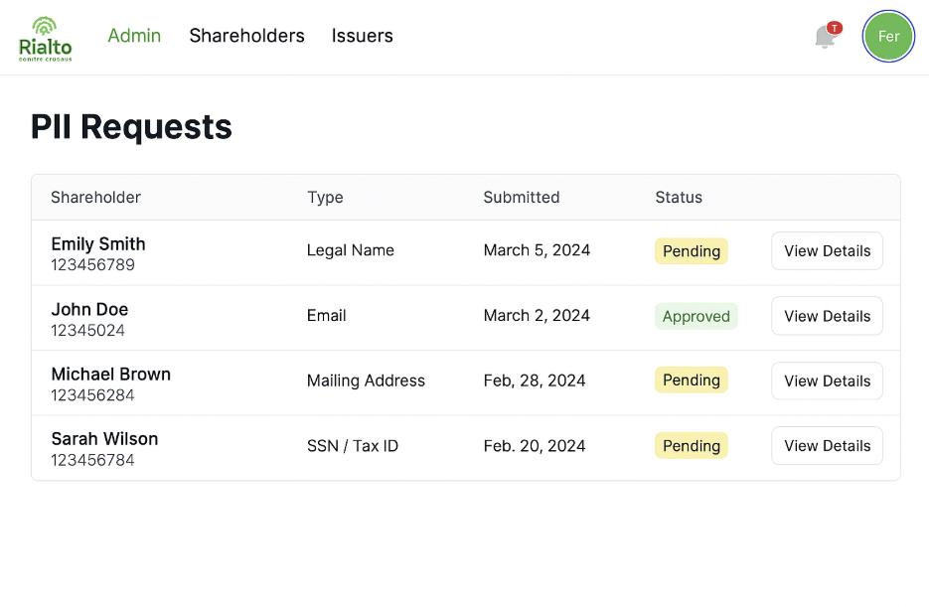

#### Step 3 – Viewing Request Details

* On clicking View Details, the operator sees:
  + Type of change requested
  + All submitted data
  + Any uploaded documents
  + Optional comments or explanations
  + A section for internal operator notes

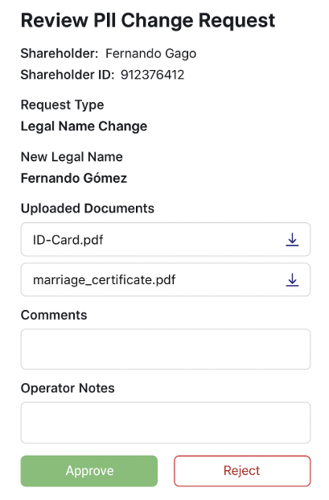

#### Step 4 – Approve or Reject

* The operator has two action buttons:
  + ✅ **Approve Request**
  + ❌ **Reject Request**
* Optionally, a rejection reason can be entered.
* A confirmation message asking “Are you sure you want to approve this request?” should be shown

Once approved, the change is executed as described below.

### 🔹 ****Workflow Overview – Part 3: Execution of Change****

#### Step 1 – Applying the Change

* The approved PII change is applied to the **shareholder's master profile**.
* If the change affects identity (e.g., Legal Name), it is also reflected in:
  + **Cap table records**
  + All relevant relationships and display names

#### Step 2 – Logging and Compliance

* The system logs the following for audit purposes:
  + Timestamp of approval
  + Operator ID
  + Final state of the record
  + Documents and comments
* All supporting materials are archived in compliance with SEC standards.

#### Step 3 – Final Notifications

##### ➤ **To the Shareholder (Change Approved)**

**Subject:** Your PII Change Request Has Been Approved  
**Body:**

Dear [Shareholder Name],

Your request to update your personal information has been approved and the change has been successfully applied to your profile.

Type of change: [e.g. Legal Name]  
Date: [MM/DD/YYYY]

If you have any questions or notice any discrepancies, please contact support at [support@rialtomarkets.com].

Best regards,  
Rialto Transfer Agent Team

##### ➤ **To All Related Companies (Cap Table Alert)**

**Subject:** Shareholder PII Update – [Shareholder Name]  
**Body:**

A shareholder with positions in your company has recently updated their personal information:

**Shareholder:** [Name] (ID: XXXX)  
**Type of Change:** [e.g. Legal Name]  
**Effective Date:** [MM/DD/YYYY]

Please note this change may impact your records, cap table, and investor communications.

Regards,  
Rialto Transfer Services

**🔹 Special Considerations**

* No KYC process is yet implemented, but we should leave integration points in case DOB/SSN changes require KYC validation in the future.
* Email address changes should support:
  + Adding a second email
  + Marking a new email as default
* Address and phone number changes may be self-service (not requiring admin approval), but this can be versioned later.

**✅ Acceptance Criteria**

* Shareholder can initiate a PII request via UI
* UI dynamically adjusts required fields based on type of change
* Documents can be uploaded and attached
* Request is visible in Rialto Operator dashboard
* Operator can approve/reject requests
* Approved changes are applied to backend records (shareholder + cap table if needed)
* Emails are triggered:
  + Confirmation to shareholder (on submit)
  + Final confirmation (if approved)
  + Alert to all companies where the shareholder has positions
* All changes and documents are stored for audit (SEC traceability)
* Log entry with timestamp and operator name